SmartMedic

|  |
| --- |
| Administrative Information |
| Document Name: | IFU (Instruction for Use) | | |
| Project Title: | SmartMedic Phase II | | |
| DHF Number: | SGTC-NPD-001-02 | | |
| Project Number: | SGTC-NPD-001 | | |
| Product: | SmartMedic | | |
|  |  |  |  |
| Document Number: | 001-02-L-13-00-00 | | |
| Current Revision: | Rev 01 | | |

|  |  |  |  |
| --- | --- | --- | --- |
| Approvals | | | |
| Approver (Role) | Name | Signature | Date |
| Marketing | Dashmeet Oberoi |  |  |
| Design Engineering R&D (Mechanical) | Salman Kapadia |  |  |
| Design Engineering R&D (Electrical) | Dushyant A |  |  |
| Design Engineering R&D (Software) | Deepak Sharma |  |  |
| Advance Quality Engineer | Sreejith Viswam |  |  |
| Regulatory Affairs | Sreejith Viswam |  |  |
| Advanced Operations (Mfg & QA) | Vikram Puri |  |  |
| Legal | Tanu Arora |  |  |

**Scope:** Scope of this document is to establish the “guidance information” and “instruction for Users” to use SmartMedic device in ICU environment

**SmartMedic**

 **Part Number: 00102A000000**

**Instruction For Use**

|  |
| --- |
| Hospital Name : |
| Hospital code : |

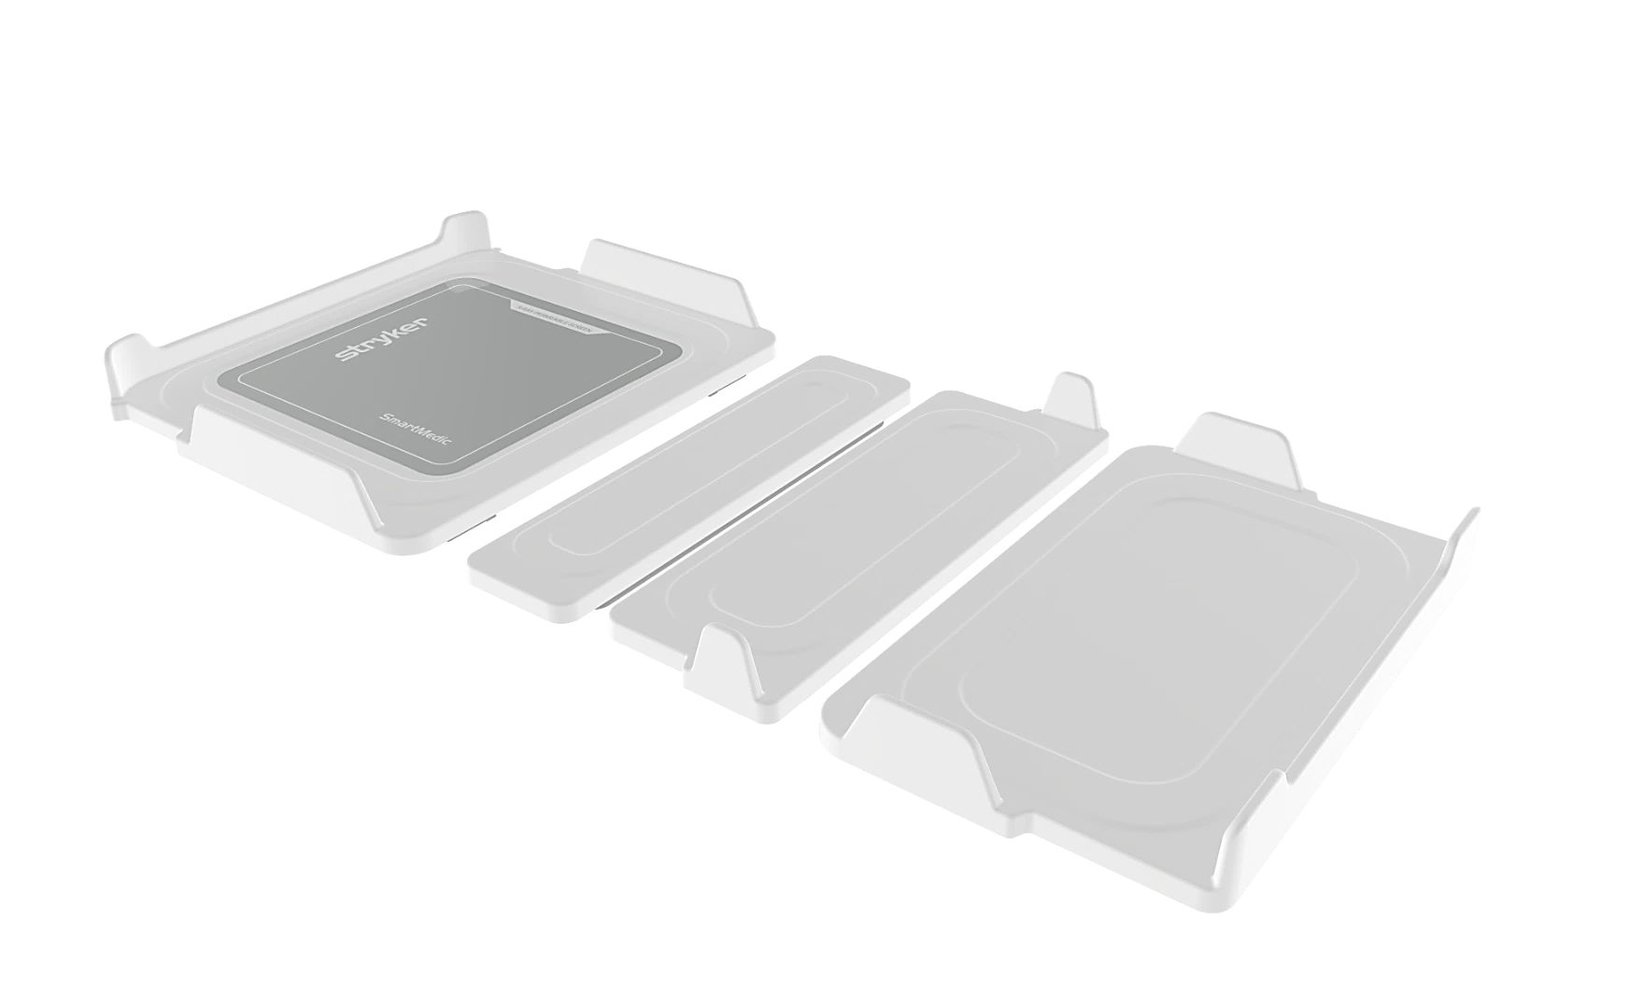

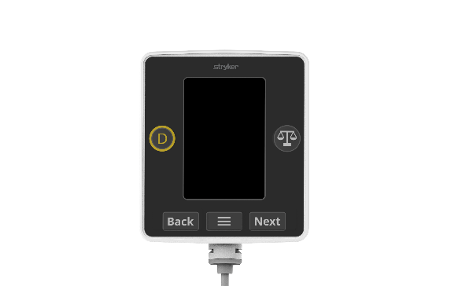

**SmartMedic**

# Symbols

|  |  |  |  |
| --- | --- | --- | --- |
| Symbols | Definition | Symbols | Definition |
| |  | | --- | |  | | Manufacturer |  | Max patient weight |
| |  | | --- | |  | | Date of Manufacture |  | Refer to instructions for manual/booklet |
| |  | | --- | |  | | Lot (Batch code) code |  | Keep Away from Rain |
| |  | | --- | |  | | Consult instructions for use |  | Fragile, handle with care |
| |  | | --- | |  | | Electrical ratings requirement |  | This Way Up |
| |  | | --- | |  | | Caution |  | Stacking Limit 5 Cartons |
| |  | | --- | |  | | Catalogue number |  | Temperature Limitation,  Operating: 15°C to 30°C  Storage: -10°C to 60°C |
| |  | | --- | |  | | Serial Number |  | Humidity Limitation, Operating: 30% to 75%  Storage: 10% to 90 % |
| |  | | --- | |  | | Safe working load |  | DC Power source |
|  | Product Disposal |  | Applied Parts Type B |
|  | AC Power Source |  |  |

# Table of Contents

Symbols 3

Table of Contents 4

Caution/ Note Definition 5

Introduction 6

Product Specifications 7

Product Functionalities 8

Standard Product Features 8

Expected service life 8

Disposal Guidelines: 8

Intended use 9

Contraindications 10

Product illustration 11

Installation 12

Handling the device 12

Device assembly on the bed after cleaning 13

SmartMedic Display Screens 16

SmartMedic Nurse Station 23

Error screen illustration 25

Using X-Ray Tray feature 27

Operation 28

Device power 28

Device setup for a new patient 29

Request patient weight 29

Patient turn schedule reminder 30

Discharge patient 30

Cleaning and maintenance 31

Cleaning instructions 31

Cleaning process: 32

Servicing /Maintenance 32

Weight testing procedure 33

Weight Test 33

EMC Information 35

Stryker representative contact information 36

Serial Number Location 36

Date of Manufacturing 36

# Caution/ Note Definition

The words CAUTION and NOTE carry special meanings and hence should be carefully reviewed.

**CAUTION:** This alerts the reader of a potentially hazardous situation which, if not avoided, may result in minor or moderate injury to the user or patient or damage to the product or other property. This includes special care necessary for the safe and effective use of the device and the care required to avoid damage to a device that may occur as a result of use or misuse.

**NOTE:** Provides special information to understand important instructions in a clear manner.

**Prevention of electric shock**

* Set up the device such that the power supply socket is easy to reach, and the device can be disconnected from the power supply quickly.
* Do not touch the power supply with wet hands.
* Do not use extension cables or power strips, the device comes with 2-meter wire length.
* Ensure that the power cable or Power Adaptor is not pinched or damaged by sharp edge or bed wheel while movement, it is recommended to disconnect power cable when bed movement is necessary.
* Only use the Stryker provided Power cord or Adaptor that is supplied with the device. Don’t use any other Auxiliary Power Cord.

# Introduction

This user guide assists you with the operation and maintenance of SmartMedic. Read this document thoroughly and ensure your staff is educated and trained on the usage and operation of the SmartMedic. This document has general safety instructions and information about the device.

 **Caution Symbol**

Improper usage of the product by the operator can cause the inaccurate weight of the patient. Operate the product only as described in this document. Modifying or tampering the SmartMedic product in any manner shall impact the performance.

**Product Description**

SmartMedic is an AC Powered (with AC to DC adaptor) device intended for use on Hospital Beds. It is designed to provide improved patient care in the hospital facility. The device is secured in place on top of the bed frame and under the bed’s mattress. The device can provide patient weight, turn indication and share information with authorized hospital nurse station. The system shares and displays information on hospital’s Nurse station through cloud application. The device also supports functionality for placing x-ray cassette without moving the patient on bed.

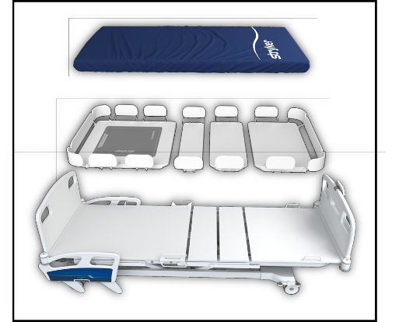

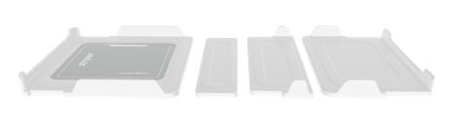

Fig. A

## Product Specifications

|  |  |
| --- | --- |
| **Model Number** | 001-02-A-00-00-00 |
| **Dimension** |  |
| Packaging box dimensions | 915 x 860 x 340 (mm) |
| Length of Head Plank | 749.9 ± 2 mm |
| Length of Abdomen Plank | 198.9 ± 2 mm |
| Length of Thigh Plank | 292 ± 2 mm |
| Length of Foot Plank | 510.2 ± 2 mm |
| Width of all the planks | 855 + 0 / -3 mm |
| Height of all planks | 56 mm ± 2 mm |
| Stryker Foam Mattress | 1880 x 830 x 120 (mm) |
| **Display size** | 3.5” TFT screen with membrane keypad |
| **Safe working load** | 135 kg (excluding mattress weight) |
| **Allowable Patient weight**  **Range** | Min: 10 kg to Max: 135 kg |
| **Allowable Patient height range** | Min. 4 ft to Max. 6.0 ft |
| **Scale interval (Resolution)** | 0.1 Kg (100 grams) |
| **Accuracy of the device** | ± 500 grams |
| **Patient Turn alert** | 2hrs, 4hrs, 6 hrs., 8 hrs., & Off timer |
| **Product weight:** | 28 kg |
| **Product weight with packaging:** | 45 kg |
| **Supports chest X-Ray only** | 15” x 18” cassette Landscape & Portrait orientation only |
| **Input Power supply (AC DC Adaptor)** | Voltage: 220-240 V (AC)  Current: 0.5 Amp  Frequency: 50/60 Hz |
| **Operating Power (DC)** | +12 V 1.0 Amp |
| **IP Rating** | IPX4 (for Display Module only) |
| **Current leakage** | <100 microamperes |
| **Hospital-grade plug** | Yes (IS 1293 certified) |
| **Operating condition** | Temperature: 15°C to 30°C  Relative humidity : 30% - 75% |
| **Storage conditions** | Temperature : -10°C to 60°C  Humidity : 10% to 90% |
| **Applied Part Type B** | Mattress |
| **Gateway Mount Assembly**  **Wi-Fi Range** | Less than 100 ft (line of sight) for each connected SmartMedic unit |
| **No. of Gateway Assembly** | To be evaluated by Authorized Stryker person based on Hospital space layout |
|  |  |

Specifications listed are approximate and may vary slightly from product to product or by power supply fluctuations.

## Product Functionalities

* The device can measure the patient’s weight on the ICU bed in the flat (Horizontal) position and display it on the Display Module in Kgs.
* The device provides notification to nurses for patient turn with set interval.
* This device’s head plank provides the provision to place an X-ray cassette (15” x18” only) in both landscape and portrait orientation.

## Standard Product Features

* Patient weight
* Weight TARE functionality
* Patient weight history and Patient turn log for entire duration of the patient stay on the Nurse Station application.
* Adjustable patient turn alarm - 2hr, 4hr, 6hr, 8hrs & OFF
* Patient Turn Alert
* Portable to other ICU beds & Compatible with limited ICU bed brands*
* Compatible with mattress overlay*
* SmartMedic display screen- LCD 3.5” tactile switch keypad Display Module.
* Nursing station web portal with data trend (weight & position logs) stored up to 6 Months.

**NOTE: \***

1. SmartMedic has been tested with supplied Stryker Foam Mattress only.
2. For portability and compatibility contact Stryker representative

## Expected service life

The SmartMedic has 4 years of expected service life under normal use conditions and with appropriate periodic maintenance.

## Disposal Guidelines:

Must be disposed of and recycled in accordance with the local environmental regulations regarding the disposal of used equipment and waste.

## Intended use

SmartMedic is intended to be used as an accessory to hospital Medical Bed for measuring patient's weight and alert caregiver to turn patient. The device is intended to take patient’s weight on medical bed in flat position. The device is intended to take weight of adult patients. Device is intended to provide relative change in patient’s weight. For pediatric patients, the device is intended to provide weight and relative changes in weight. The device intends to give patient turn notification for the adult patient only. Device is intended to be used in Indian hospital environment.

The device is intended to help caregiver to place x-ray cassette without moving the patient.

The device is intended to take the patient’s weight on an ICU bed in a **flat (horizontal) position** for adult and pediatric patients. The device intends to give patient turn notification for the adult patient only.

While taking the weight, the user needs to make sure that patient is not **touching** the bed footboard/headboard and placed in a Supine/Prone/Left or Right Lateral position at the central line of bed/mattress. **The bed must not have any extra equipment/device like an oxygen cylinder/infusion pump etc. while taking the weight of the patient**. The maximum safe working load (excluding Mattress) for SmartMedic is 135kg. The safe working range of this device is designed **for patients weighing more than 10 kg and less than 135 kg**. The device is designed for the patient having height starting from 4 ft and up to 6.0 ft. SmartMedic device has provision to place X-ray cassette in Tray provided in head plank to place precisely 15”x18” X-ray cassettes either in landscape or portrait orientation. **It is advised to take an X-ray image under the clinician’s supervision, and he/she shall take any clinical decision**.

 Stop using the device if the device does not function as per intended use.

 Ensure no part of the patient body touches any part of the bed while fetching the weight.

 Ensure the mattress is not touching any part of the bed while fetching the weight.

 Ensure that no additional weight shall be kept on the device while fetching the weight of the patient.

 With multiple SmartMedic installation, ensure that Display Module & Planks must not be interchanged, as this might leads to inaccurate data.

 Ensure Gateway Device is always connected to Power Supply.

 Few functions may not work if Gateway Mount Assembly is outside specified Wi-Fi range.

## Contraindications

The device is not intended to come in contact with the patient during intended use. A patient must not be rested directly on the device without a bed mattress. However, there can be momentary patient contact with the device side periphery (plank plastic) during entry and exit from the bed. SmartMedic is NOT intended to:

* be used with mattress size other than specified in the product specification
* be used for more than one individual at a time
* use the scale output to determine diagnosis or treatment
* use with any additional equipment/device placed on the ICU bed
* Be used for a patient height of more than 6.0 feet and less than 4.0 ft
* Be used for infant patients
* be used for patients whose weight is less than 10 kg or more than 135 kg
* be used when the bed is inclined at 5-degree or more
* be used with the pediatric patient for patient turn notification functionality
* be used in an environment outside the hospital.
* be used in the presence of flammable anesthetics
* be used for any different size of X-ray cassette other than the specified

 Caution: This device must not be used for diagnostics. It simply assists the treating physician in establishing the diagnosis. To make a precise diagnosis and initiate the therapeutic measures, besides the determination of patient weight, further targeted examinations must be set up by the physician and expert health care professional, their results must be considered.

## Product illustration

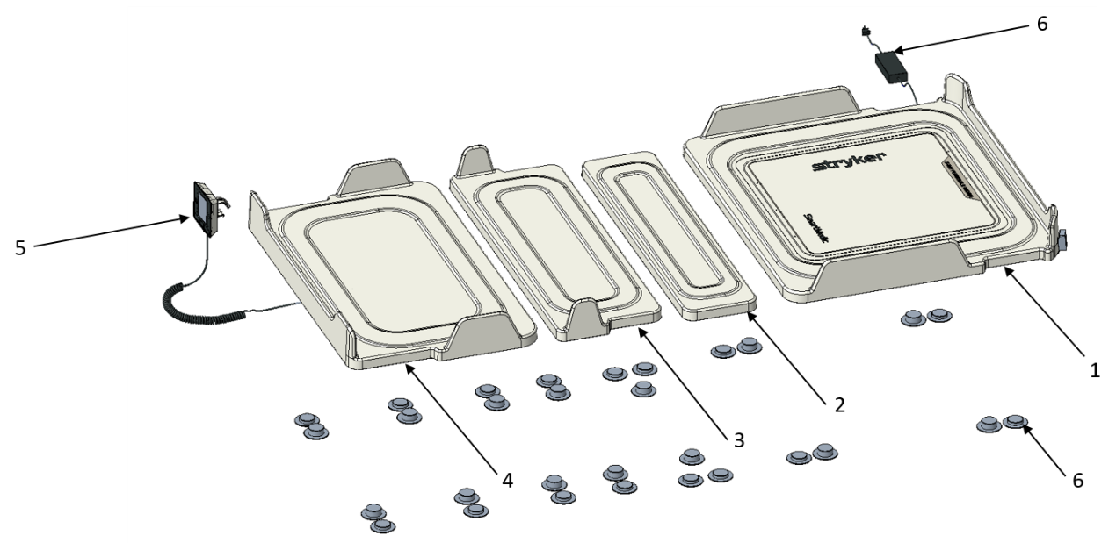

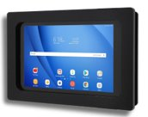

11

Fig. B

|  |  |  |  |  |  |
| --- | --- | --- | --- | --- | --- |
| **Items included in SmartMedic package** | | | | | |
| **Item** | | **Part no.** | **Description** | **Quantity** | |
| 1 | | 001-02-A-01-00-00 | Head Plank Assembly | 1 | |
| 2 | | 001-02-A-02-00-00 | Abdomen Plank Assembly | 1 | |
| 3 | | 001-02-A-03-00-00 | Thigh Plank Assembly | 1 | |
| 4 | | 001-02-A-04-00-00 | Foot Plank Assembly | 1 | |
| 5 | | 001-02-A-05-00-00 | Display Module Assembly | 1 | |
| 6 | | 001-02-M-01-12-00 | Anchoring Peg, Bed Side, Type-1 | 16 | |
| 7 | | 001-02-M-01-13-00 | Anchoring Peg, Bed Side, Type-2 | 14 | |
| 8 | | 001-02-E-06-00-00 | Plank to plank cable | 3 | |
| 9 | | 001-02-A-07-00-00 | Power adaptor assembly | 1 | |
| 10 | | 001-02-A-08-00-00 | X-Ray Tray Assembly | 1 | |
| **Additional Accessories** | | | | | |
| 11 | 001-02-A-09-00-00 | | Gateway Mount Assembly | | 1 |

# Installation

## Handling the device

Please observe the information in this user manual for the careful handling of the device.

Installation will be done by Stryker authorized persons only as per Installation Manual - D001020092

Stryker will make available circuit diagrams, component part lists, descriptions, or other instructions to assist the Service Personnel to diagnose/service the unit.

 Any changes to the device are not permitted. The unit contains no user-serviceable parts. **Ensure the installation, maintenance, and repair are to be done only by authorized Stryker personnel only.**

 Ensure mattress shall not bulge out after angulating and keeping in flat position. If observed, gently push the mattress within the specified area to ensure correct position.

 Before initiating the SmartMedic installation on bed, ensure bed platform is not damaged i.e., deformed, or broken. Such installation will lead to inaccurate output.

 Device shall only work in any single mode i.e., ***ICU Mode*** or ***Dialysis Mode*** which has been selected by the Stryker Installation person (as per Customer requirement) at the time of First Installation. Raise the request to make any changes in the same.

The SmartMedic is designed to lay on top of the flat surface of the bed’s frame. The device consists of four segments which also called out as planks in this document, which are connected by three connecting cables. The head plank is connected to the power adaptor connector, and the foot plank is connected to the display device connector cable, which should be secured at the footboard of the ICU bed. The device shall have anchors placed on the bedside surface with templates by authorized Stryker personnel.

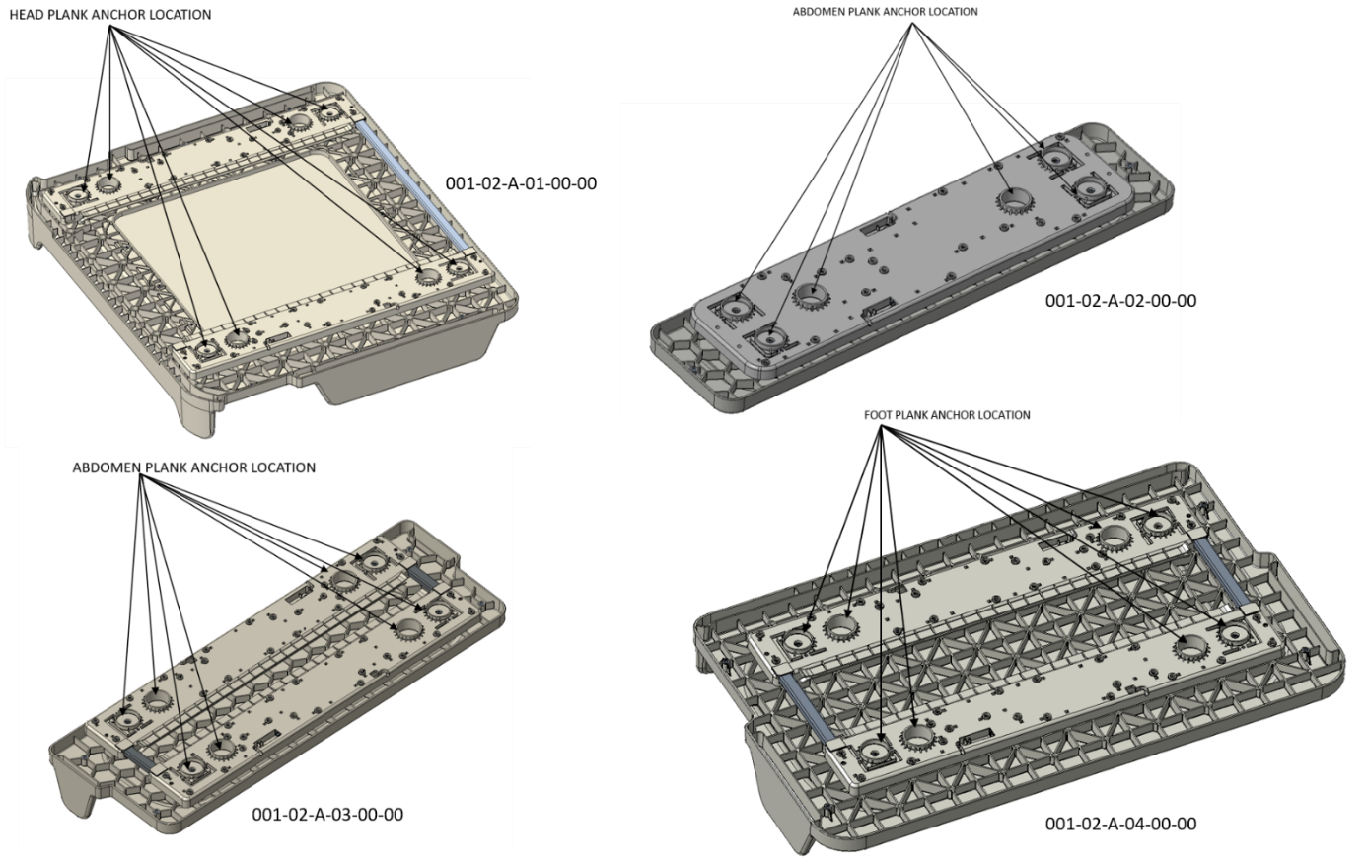

Fig. C

## Device assembly on the bed after cleaning

1. As described in the handling section, the four planks need to be placed on anchors on the surface of the bed, check the stability of planks on the bed before putting the mattress back.
2. The anchors are used to secure the device in position and to prevent any device slippage.
3. Next, each of the segment is connected to the adjacent section with standard cables, (as shown in Fig. H)
4. Connect the display spiral cable to the foot segment. (as shown in Fig. D)
5. Carefully secure the display unit appropriately on the footboard of the ICU bed. Make sure the clip of display unit is tightly secured (as shown in Fig. F and Fig. G)
6. Plug the power cord of the SmartMedic into a grounded hospital-grade wall outlet & switch on the power of the device.

**Note:** Power Cord must be attached with the power socket & Power Adaptor Assembly.

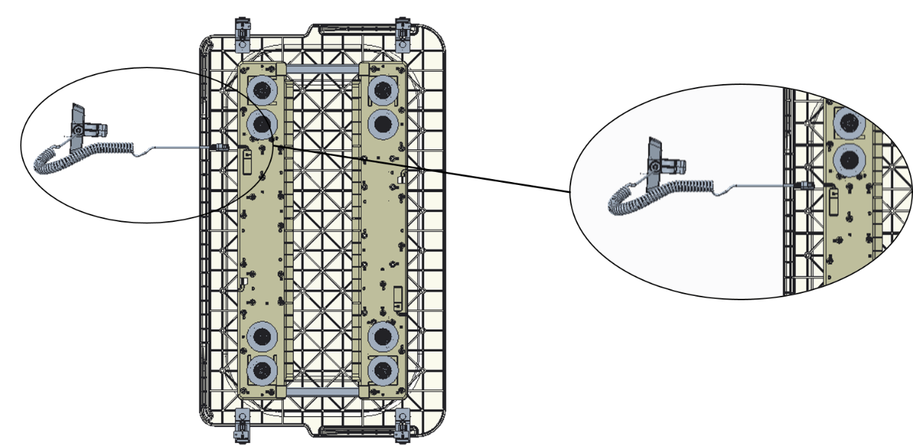

Fig. D

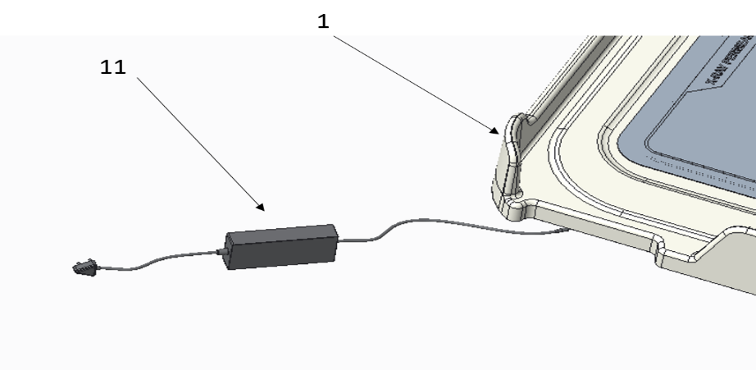

Fig. E

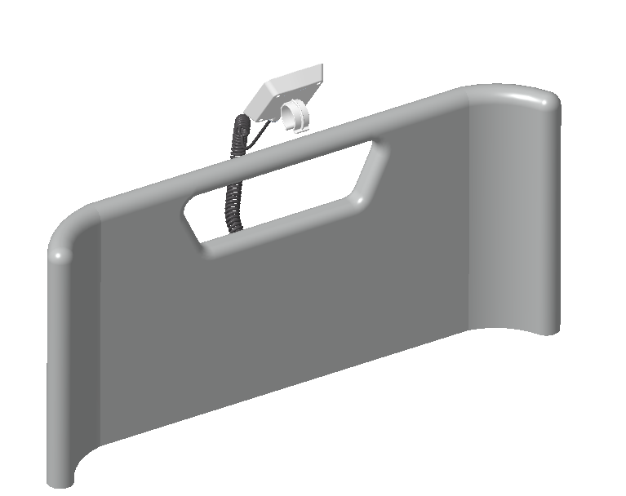 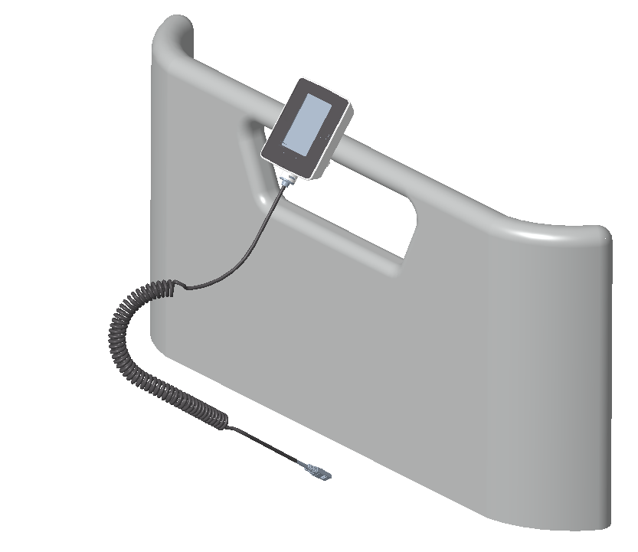

Fig. F Fig. G

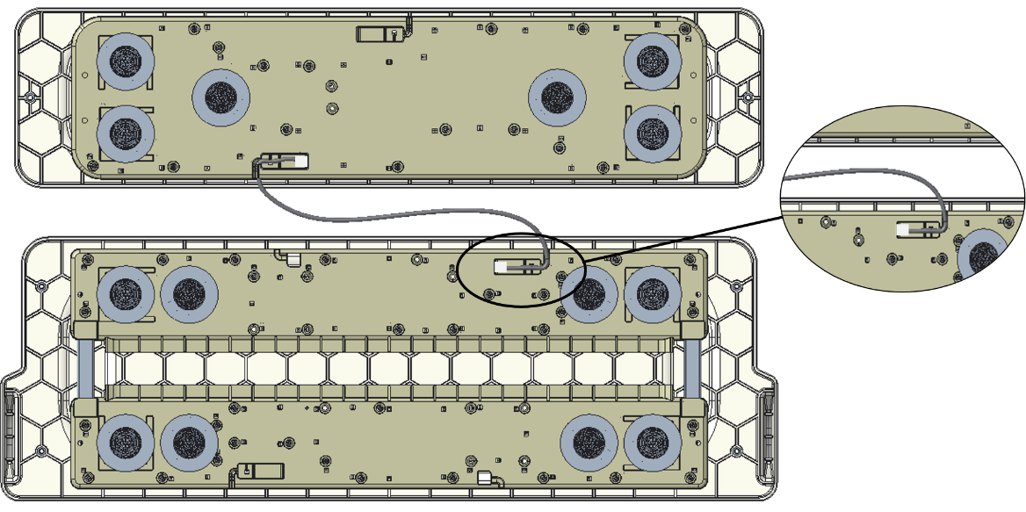

Fig. H

**Note:** The Patient Support Platform height will be increased by 50-60 mm after installation of SmartMedic on Bed.

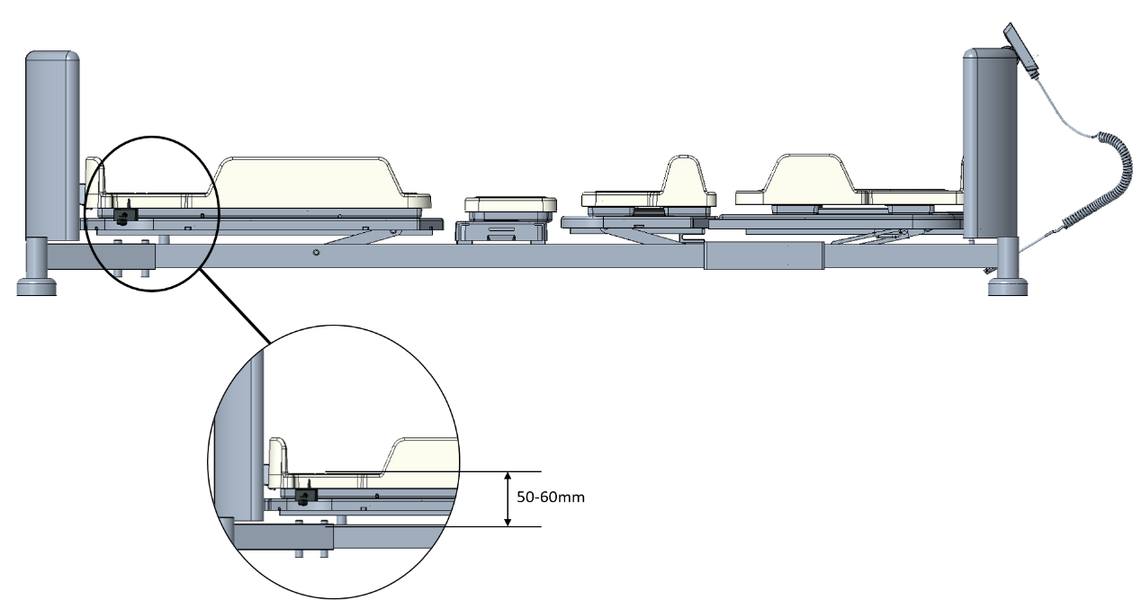

## Icon Description automatically generated The safe use of the SmartMedic is maximized when used in conjunction with side rails; there may be an increased risk of falls when side rails are not present. Local policies regarding the use of side rails should be taken into account. Whether and how to use side rails is a decision that should be based on each patient’s individual needs and should be made by the physician, operators, and responsible parties.

There is a Risk of patient fall due to increase in platform height by 50 to 60 mm while Using SmartMedic along with Beds. Users shall carefully evaluate this Risk and follow facility protocols related to patient fall prevention.

## SmartMedic Display Screens

* ***For ICU Mode:***

To use the device, connect SmartMedic adaptor to the power socket. Below screens shall be displayed once the device powers up (as shown in Fig. 1)

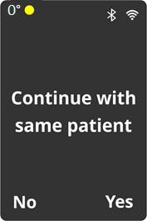

Fig. 2

Fig. 1

The **“Stryker”** Screen will automatically transition to **“Continue with same patient”** (as shown in Fig. 2). On pressing **“Back”** button, option **“No”** will be selected*.

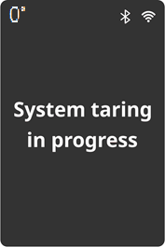

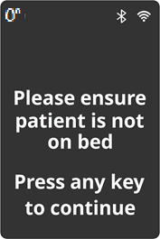

Fig. 3

Fig. 4

The screen, (as shown in Fig. 3) will appear. Pressing any button starts taring and then navigates to **“System taring in progress”** screen (as shown in Fig. 4).

Ensure necessary routine items are placed on the bed before starting the TARE function; it is essential to **zero the weight** of accessories/items on the bed. There will be a successful taring notification (as shown in Fig. 5), Bio-med or Nursing staff MUST ensure these steps are completed before putting the patient on the bed.

~~~~Ensure the tare function has been completed before admission of the new patient.

~~~~Discharge the previous patient before admitting the New Patient on the device.

*When initiating the fresh system, this screen will not be the part of booting worikflow.

~~~~Ensure the Bed Side display module has the network connectivity with appropriate symbols to represent Wi-Fi & BT connectivity.

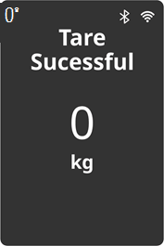 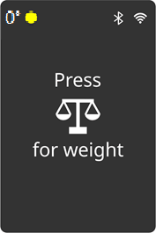

Fig. 5

Fig. 6

The screen will show message **“Tare Successful”** and tare weight in Kg (as shown in Fig. 5). Pressing any key traverses to **“Get Weight”** Screen (as shown in Fig. 6).

Press **“Get Weight”** to process weight on the screen. It will show message **“Calculating weight”** (as shown in Fig. 7). Weight of the patient is displayed in Kg, along with date and time when the weight was calculated (as shown in Fig. 8).

Also, change in weight +ve or –ve from last reading will be displayed (as shown in Fig. 8).

 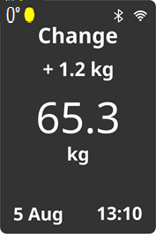

Fig. 8

Fig. 7

The device allows the user to see the previous five weight readings of the patient logs. By pressing **“Menu”** button, the screen shall show 4 menu options to be selected :

**“Weight History”**, “**Turn timer”**, “**Turn History”**, “**Settings”** (as shown in Fig. 9). Press of **“Next”** shall scroll through *Four* menu options. Cursor position on any option shall be highlighted by yellow color. **“Menu”** button shall select the particular option highlighted.

Selecting **“Weight History”** shows last *Five* weight data. The **“Next”** button shall scroll through previous 5 weight data along with date and time in descending order. After the oldest of data entry (5th), it shall circle back to the latest data entry (1st) (as shown in Fig. 10).

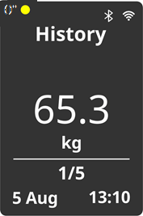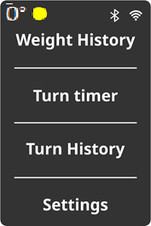

Fig. 9

Fig. 10

To use the Patient Turn notification functionality, press the **“Menu”** button and Select **“Turn Timer”** on the screen that will leads to Timer screen as shown in Fig. 11. Press of **“Next”** scrolls through all the Timer options i.e., **2hrs**, **4hrs**, **6hrs**, **8hrs**, & **OFF**. Press **“Menu”** button to select the displayed timer option. **“Selected”** will be displayed to confirm.

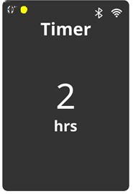 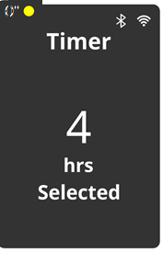

Fig. 11

The device allows the user to see the last *Five* turn time values. By pressing **“Menu”** button, select **“Turn History”** to show the screen as shown in Fig. 12. The **“Next”** button shall scroll through previous *Five* turn time values along with date and time in descending order. After the oldest of data entry (5th), it shall circle back to the latest data entry (1st)

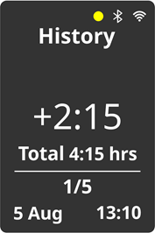

Fig. 12

User can go back to the Get weight screen by pressing **“Back”** button until screen as shown in Fig. 13 displays.



Fig. 13

Once the patient is discharged from ICU, the user MUST discharge the patient from the SmartMedic device. For discharging patient, long press **“Discharge”** button for 2 seconds. The screen as shown in Fig. 14 will display. On press of **“Next”** button, option **“Yes”** will be selected, and patient will be discharged. Screen will display **“Patient Discharged”** to confirm (as shown in Fig. 15).

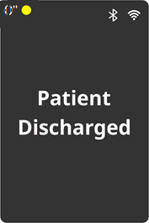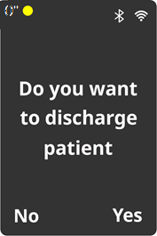

Fig. 14

Fig. 15

Once the bed is clean, repeat the process for bed set up as shown from Screen 1 to 6 of this section.

* ***For Dialysis Mode:***

To use the device, connect SmartMedic adaptor to the power socket. Below screens shall be displayed once the device powers up (as shown in Fig. 1)



Fig. 2

Fig. 1

The screen will show **“Continue with same patient”** (as shown in Fig. 2). On pressing **“Back”** button, option **“No”** will be selected.





Fig. 3

Fig. 4

The screen, (as shown in Fig. 3) will appear. Pressing any key starts taring and then navigates to **“System taring in progress”** screen (as shown in Fig. 4).

Ensure necessary routine items are placed on the bed before starting the TARE function; it is essential to **zero the weight** of accessories/items on the bed. There will be a successful taring notification (as shown in Fig. 5), Bio-med or Nursing staff MUST ensure these steps are taken before putting the patient on the bed.

~~~~Ensure the tare function has been completed before admission of the new patient.

~~~~Discharge the previous patient before admitting the New Patient on the device.

 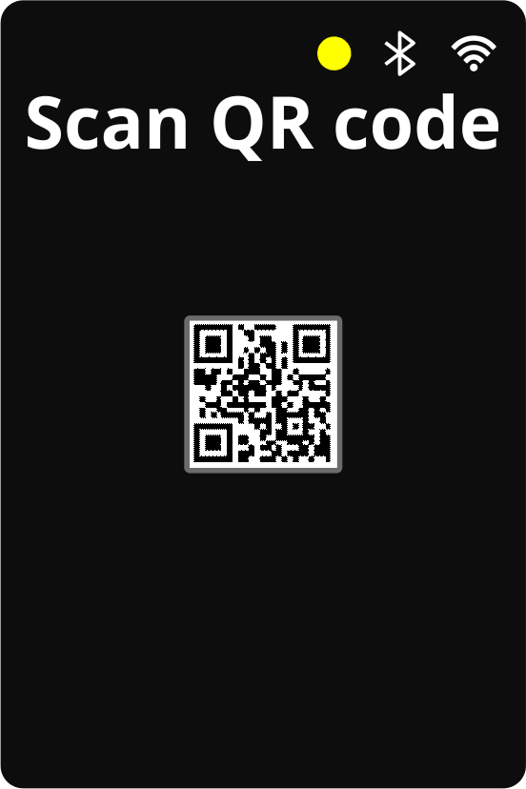

Fig. 5

Fig. 6

The screen will show message **“Tare Successful”** and also post tare weight in Kg (as shown in Fig. 5). Pressing any key or after 3 sec it automatically traverses to **QR Code Screen** (as shown in Fig. 6).

On successful registration of patient, the screen shall exit to patient registered confirmation screen.

**Note:** User can skip QR code scan by long pressing (2 sec) **“Get Weight”** button, which traverse to Start Weight confirmation screen.

**“Get Weight”** will process start weight screen. The screen will show message **“Calculating weight”** (as shown in Fig. 7). Start weight of the patient shall be displayed along with date and time (as shown in Fig. 8).

 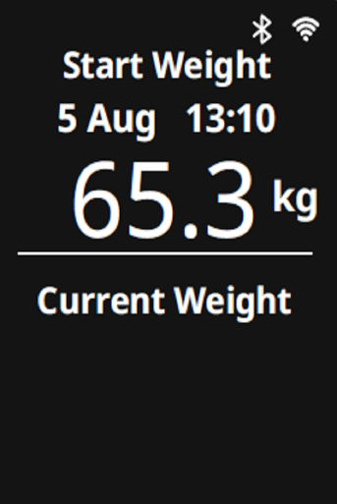

Fig. 8

Fig. 7

On second press, **“Current weight”** date, time and Current Weight will be displayed (as shown in Fig. 9). The weight value in the “Current Weight” would get change whenever the **“Get Weight”** button in pressed.

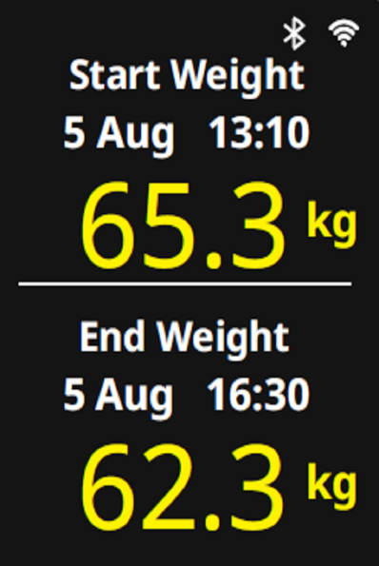 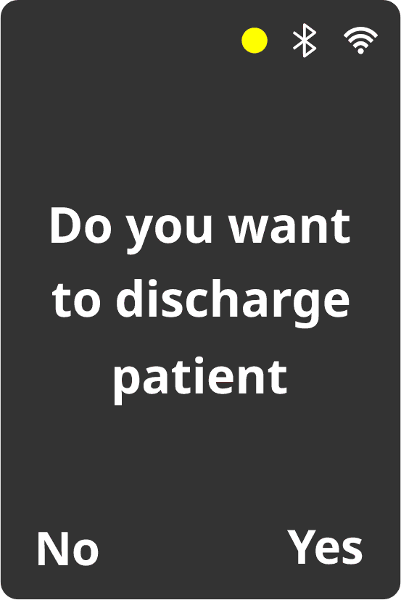

Fig. 9

Fig. 10

After the long press (2 sec) of **“Discharge button”**, the patient discharge confirmation screen pops-up as shown in figure 10. With **“Next”** button “Yes” can be confirmed to proceed for patient discharge. Resulting in **“End Weight”** to be displayed on the screen along with the **“Start Weight”** as shown in figure 9.

The screen will automatically timeout after 30 sec to **“QR Code Screen”** for admitting new patient.

**Note:**

If **“Menu”** Button is pressed when the **“Start Weight”** is displayed on the screen, **“Weight History”**, **“Settings”** & **“Update Start Weight”** options can be selected as shown in figure 11.

**“Next”** button is used for scrolling within the options while **“Menu”** button is used for selecting the option.

For **“Weight History”** & **“Settings”** follow the same instructions as mentioned in ICU mode in above section.

Selecting **“Update Start Weight”** shall save the current weight to **“Start Weight”**.

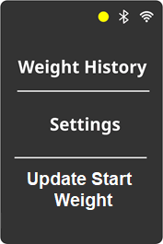 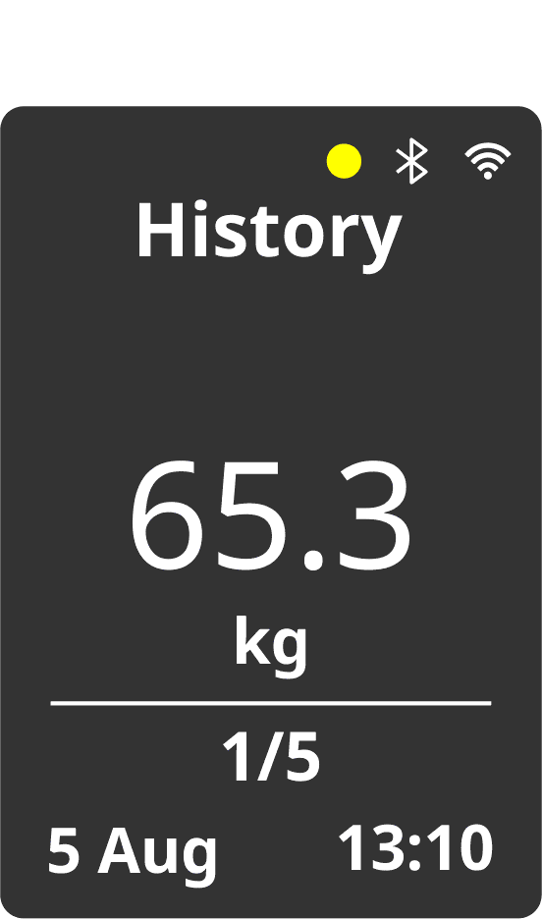

Fig. 12

Fig. 11

## SmartMedic Nurse Station

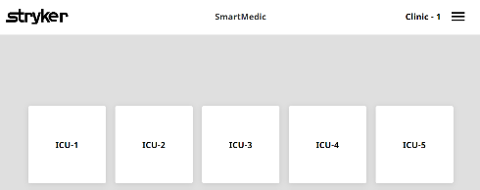

Fig. 16

To access the patient record on Nurse station, ensure the web portal is working, internet connectivity is there on nursing station and device have 4G or Wi-Fi connectivity.

For more information, please contact Stryker representative or local hospital IT administrative team. The link of the web portal is as below:

<https://smartmedic.stryker.com>

If home page is not accessible, please contact your IT administrator.

When user see the Stryker screen, he/she needs to put the Hospital code in the message window and submit. After submitting user will see the ICU list in which SmartMedic is placed (as shown in Fig. 16). User can select required ICU by clicking on it.

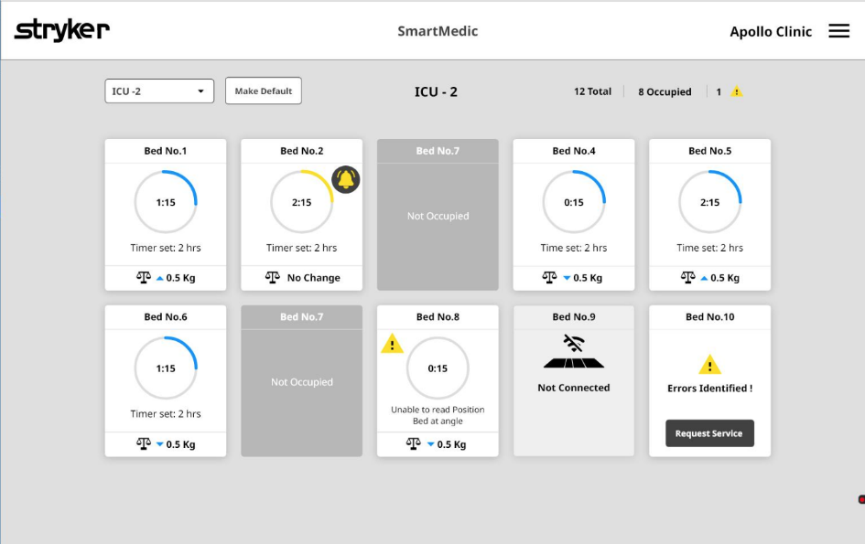The user will see the default dashboard screen (as shown in Fig. 17). User will be able to see the list of SmartMedic enabled beds on the dashboard screen. User can also select the default ICU for their convenience, (as shown in Fig. 17). To change the default ICU, user needs to confirm the change in default ICU, (as shown in Fig. 18).

Fig. 17

Each Bed screen will display the real-time duration from the last patient position against the set timer and over the exceeded duration, change in weight from the previous two demanded weight of the patient. If the device is not connected or any other issue user should be able to get information from the dashboard.

User should be able to select the bed number screen in (as shown Fig. 17). After selecting the bed number screen user will have to enter the “Patient ID” (as shown in Fig. 19). After entering required information user will be able to get into details of patient weight trend and turn the trend of the respective ICU bed (as shown in Fig. 19).

Fig. 19

Fig. 18

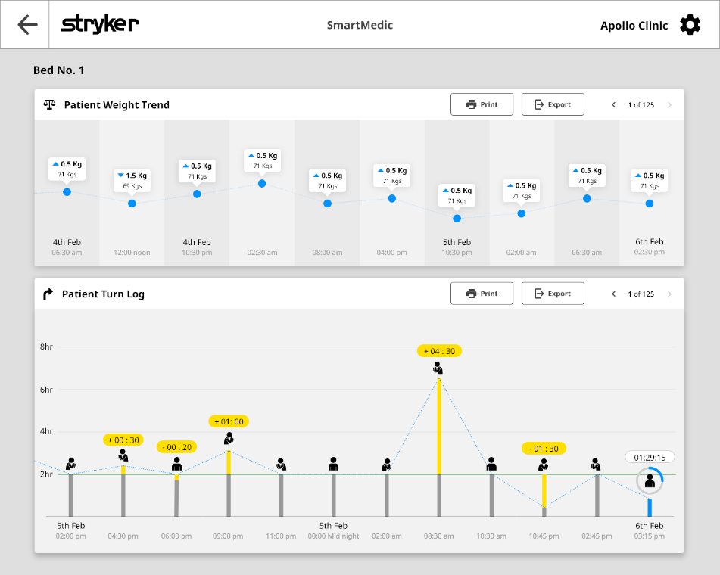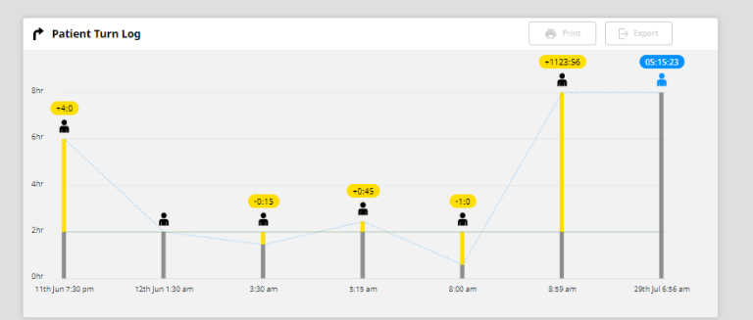

Fig. 20

User should be able to review the weight trend of the specific patient admitted to a bed. In the second half of the chart, the user can review the patient turn history. (as shown in Fig. 20).

## Error screen illustration

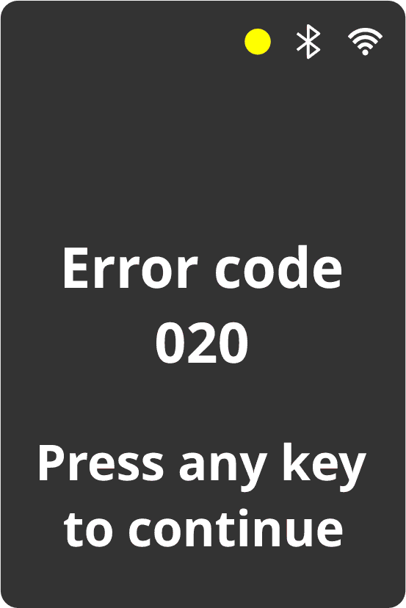

Fig. 21

Fig. 22

Reboot the system power (as shown in Fig. 21 & 22), in case of error screen, please follow the below steps:

1. The system performing self-diagnostics – this process might take approx. 1 min to finish.
2. In case system encounters an error during self-diagnostics, an error is displayed

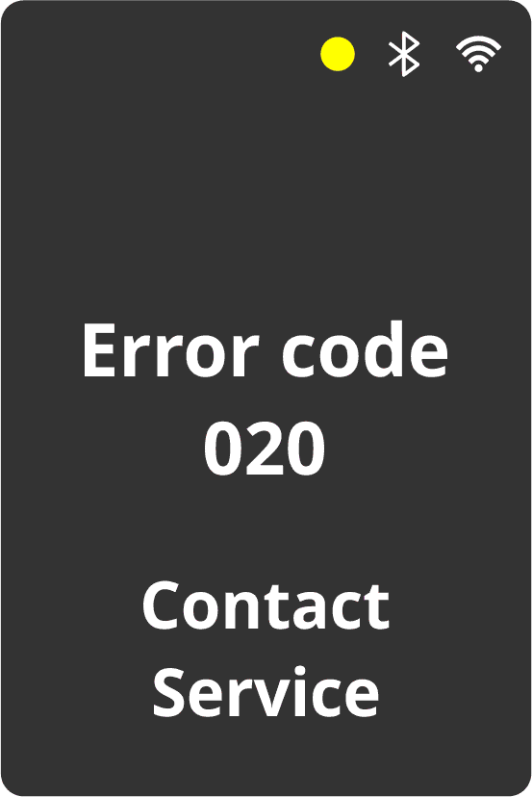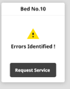

Fig. 23

In case of error, the nursing station dashboard will show error window of faulty device (as shown in Fig. 23). User can submit request service either pressing the tab “Request service” or the user can use the mail id or toll-free number for the booking service request (as shown in Fig. 23).

User can access the “Spare List” (as shown in Fig. 25) for replacement of the parts that are damaged in the field.

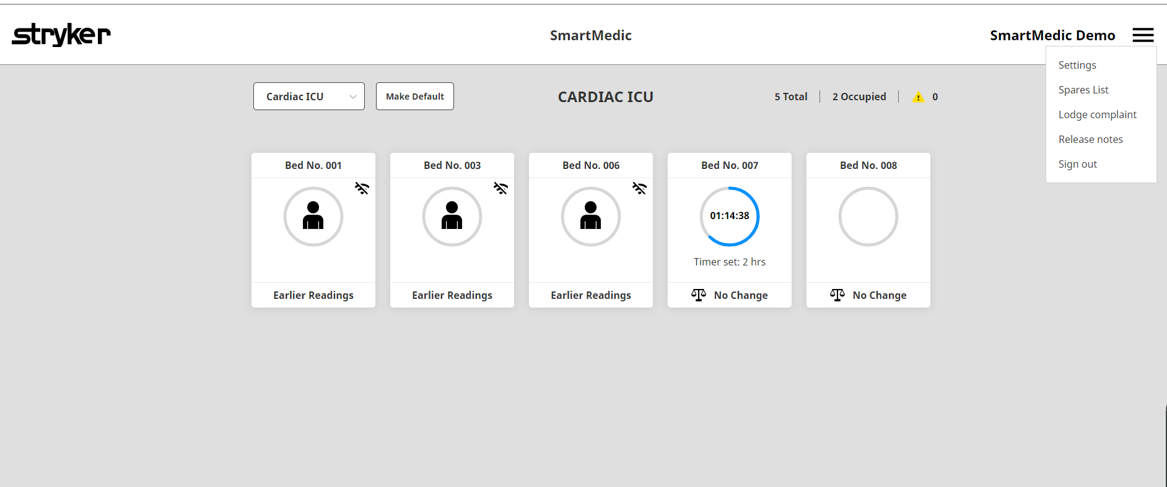

Fig. 25

In case if display screen shows error or is unresponsive (display screen does not work), User can submit request service either pressing the tab “Request service” or the user can use the mail id or toll-free number for the booking service request (as shown in Fig. 29).

In case if the connectivity symbol is not displayed on the display screen (as shown in fig 33), please reboot the system and if the issue persists, User can submit request service either pressing the tab “Request service” or the user can use the mail id or toll-free number for the booking service request (as shown in Fig. 29).



Fig. 27

**Error Code List**

|  |  |
| --- | --- |
| **Error Code** | **Description** |
| 010 | CPU Error |
| 011 | Flash Error |
| 012 | RAM Error |
| 013 | LCD Error |
| 014 | Slave Error |
| 017 | Keypad Error |
| 018 | Sound Error |
| 020 | BT Error |
| 021 | Wi-Fi Error |
| 022 | Tablet Error |
| 023 | Socket Error |
| 030 | Taring Error |
| 031 | Stabilize Error |
| 032 | Over Range Error |
| 033 | Turn Timer Set Event |
| 034 | Tilt Error |
| 040 | Power ON Reset Error |
| 041 | Push Button Reset Error |
| 042 | Watchdog Reset Error |
| 043 | Soft Reset Error |

## Using X-Ray Tray feature

SmartMedic Head Plank has provision of X-ray tray to hold X-ray cassette of size 15 x 18 inch only in portrait & landscape orientations. While using the X-Ray tray, make sure the accessibility of Tray towards the head side of the bed. It can be achieved by removing the headboard of the bed and keeping the bed at flat & horizontal position. Ensure X Ray cassette is placed before taking X ray.

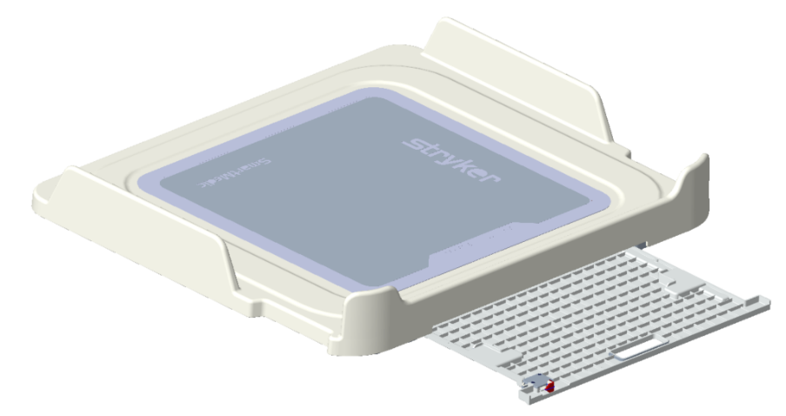

Fig. 28

Care must be taken while inserting & extracting the X-ray tray in the Head Plank to avoid any finger entrapment.

 X-ray Tray must not be inserted when Head Side is inclined. Shall always be used when bed platform is Flat & Horizontal.

# Operation

## Device power

The device is functional only when connected to the external power socket. When the power adaptor is disconnected, the device shuts off. Patient history will be available on the device and at nursing station, when device is re connected to power, user shall be able to access the patient history.

User must ensure removing the power cable from the electrical socket before movement of ICU bed and ensure the power plug is inserted back when ICU bed is back in ICU at its dedicated place.

User should ensure turning off the power when CPR is being given to the patient

To avoid risk of electric shock, this equipment must be connected to a supply main with protective earth only.

The operator of the device (nurses, intensivist or doctors) must be trained by authorized **Stryker personnel** only.

## Device setup for a new patient

Each time the bed and mattress are cleaned after a patient is discharged, the device must be removed from the bed and cleaned by wiping it down with hospital-grade cleaning wipes as per the protocol specified in the cleaning section of this document. See below cleaning section for more details. Once the device is cleaned, put the device back on the anchors assembled on the bed surface. Connect the P2P cables, as mentioned in the assembly section of this document. Connect the power adaptor to a power socket to power the device ON. Follow steps in Fig. 1 to 6 for system setup.

## Request patient weight

User can request for patient weight anytime by pressing the **“Get weight”** button. The patient weight can be demand at any time using the below screen (Refer Fig. 29).



Fig. 29

weight must be taken in a flat (horizontal) position to ensure accurate weight

mattress is not touching the bed or surrounding bed structure to get an accurate weight

Patient shall be positioned centrally on the mattress & no body part must touch the ICU bed for an accurate weight.

Caution: This device is not a diagnostic device. It simply assists the treating physician in establishing the diagnosis. To make a precise diagnosis and initiate the therapeutic measures, besides the determination of patient weight, further targeted examinations must be set up by the physician and expert clinician, and their results must be considered.

The SmartMedic allows for viewing of the patient trend chart throughout the patient stay, (as shown in Fig. 20)

Note: During weight measurement ensure that mattress must not be lifted off, if observed it must be pushed down to SmartMedic platform gently with hands.

## Patient turn schedule reminder

The default setting on the device is to provide the patient with a turn reminder of default values. Once the set time elapses, an alarm will sound as a reminder for the caregiver to turn the patient. The caregiver will need to turn the patient and the device will sense the patient position change and timer will reset to default timer and show the remaining laps time for next turn notification.



Fig. 30

## Discharge patient

Once a patient is ready to be shifted out of ICU, it is essential to discharge the patient from the SmartMedic. To discharge the patient, long press **“Discharge”** button for about 2 seconds. The screen (as shown in Fig. 31) will display. On press of **“Next”** button, option **“Yes”** shall be selected, and patient shall be discharged. This helps to ensure that device is ready to record new patient data once admitted, before admitting the patient please follow the steps as shown from Fig. 1 to Fig. 6.



Fig. 31

# Cleaning and maintenance

**CAUTION**

* Service & repair of system MUST be done by authorized Stryker service personnel only , for any assistance please log the request as mentioned in Error screen illustrative section.
* Do not clean, service, or perform maintenance on the device while it is in use or power is connected.
* Always unplug the power cord before cleaning, servicing, or performing maintenance.
* Always unplug the power cord from the wall outlet when large fluid spills occur near the device. Do not use the device, contact a Stryker personnel to inspect the product before putting the SmartMedic device back to use.
* Fluids can cause unpredictable operation and decreased functionality of any electrical product/ device.
* Chemical used for cleaning shall be as per below recommendation
* Contact Stryker service personnel if any malfunction is observed
* Avoid using the Display Keypad with wet hand.
* Ensure the plank to plank cable must not touch the top surface of the plank before placing the mattress over it.
* Cleaning Instructions with defined chemicals (Refer cleaning section below)
* Trained biomed staff need to verify the routine check-up on monthly basis by using checking method as described in testing section. In case of any variance please inform the issue in issue log and don’t use the unit until it is checked by Stryker personal.

**CAUTION**

* Do not steam clean, wash or immerse any part of the device in water or any other liquid. Dipping in water or any other liquid may damage the internal electric parts.

## Cleaning instructions

It is recommended to use cleaning wipes to clean the device before admitting new patient. Cleaning agents, as per the hospital cleaning process, can be used. Avoid oversaturation and make sure the device does not stay wet longer than the chemical manufacturer’s guidelines for proper disinfecting.

Recommended cleaning agents to clean SmartMedic are as below:

Chemical Names-

* Alcoholic Solution            :  Bacillol 25
* Phenolic Solution             :  Dettol
* Sodium Hypochlorite

*Note: For cleaning the Display module outer casing, use wet alcoholic wipes or IP solution. Ensure the display module casing surface must be dry after the mentioned cleaning cycle is performed.*

## Cleaning process:

1. Inspect the ICU Bed over which Smart Medic is installed.
2. Wear the basic protective equipment, i.e., gloves, Face Mask, etc. to ensure safety.
3. Remove all the electrical connections, i.e., power cable, Plank to Plank cables & Display connection.
4. Remove all the planks from the bed platform.
5. Use the above mentioned disinfectants over the defined area for exposure (Alcoholic composition or Phenolic composition or Sodium Hypochlorite (50 ppm)) spray over the defined area for the exposure time of 2 min.
6. Defined Area for Cleaning:

* Anchoring interference on bottom plank
* Top and Bottom surface of all four planks
* X-ray tray handle and cassette region

1. Wipe the surface with a dry clean cotton cloth.
2. Ensure the SmartMedic system, along with the display module, are dry before installation.
3. Disinfect the bed platform with any spray mentioned above before installing the system.
4. Thoroughly disinfect & clean the anchoring parts pasted on the bed platform.
5. Place the system over the bed platform at desired positions, ensuring no lift-off in the planks.
6. Make all the electrical connections to make the system up & running.
7. System is ready to use.

Caution: Contact Stryker personnel immediately if the device does not function as intended.

Cleaning of the device must be done by a trained nurse or Biomed staff.

## Servicing /Maintenance

Software version upgrade and cable connections will only be done as a part of service on the installed devices at hospitals. In case of any product failure the non-functional units will be replaced by a standby SmartMedic unit.

As a routine maintenance, Stryker recommends periodic cleaning of device at site, A trained biomed engineer from hospital should inspect the device with calibrated weight to check the accuracy of device over usage of one month on monthly basis and should record the values, calibrated weight should be available at site while doing the check. as shown in below steps:

## Weight testing procedure

Biomed engineer or quality personal from hospital should contact Stryker representative if device is not functioning as intended (including accuracy of weight as specified in product specification section). SmartMedic is not serviceable at site. Stryker representative will take the decision to service or calibrate if required at due course of time. Stryker will replace the device with standby unit during the annual maintenance of the device.

Please ensure hospital has the calibrated 5 kg & 20 Kg weight for ensuring accuracy range.

## Weight Test

1. Power ON the device, ensure no object is kept on the bed
2. Perform bed setup and taring as Steps shown in Fig. 1-6 in SmartMedic display screens section.

 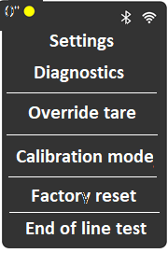

Fig. 32

1. Once the user tares successfully, press **“Menu”** button and a screen as shown in Fig. 32 will appear. Please scroll to **“Settings”** by pressing **“Next”** button. Press the **“Menu”** button and setting options will appear.
2. From the list select **“Diagnostics”**. Select **“Weight”** (as shown in Fig. 33) to test weight accuracy of individual planks (as shown in Fig. 34).

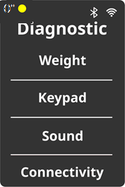

FIG. 33

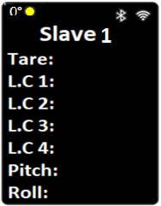

FIG. 34

1. Place 5 Kg (calibrated weight available in hospital) on plank #1
2. Press “Get Weight”. Plank weight shall be updated, verify displayed weight is same as the weight kept on the plank
3. Repeat the Steps 5 & 6 for plank 2, 3 & 4 and record the displayed weight.
4. Repeat the steps 4 to 7 with 20 kg weight.
5. If displayed weight is off by more than ***500 g*** in either of calibrated weight, please raise a customer feedback request and immediately stop using the device

**NOTE**:

Clause 1: Stryker ensures that the product is fit for the intended purpose, and shall provide a replacement, maintenance, and repair services at its own cost till a period of 12 months from installation date in case of any defect is found in product design, material or manufacturing.

Clause 2: Any damage to the product due to tampering or mishandling, any modification in the product or any repair is done without permission from Stryker will result in the lapse of clause 1

# EMC Information

Portable and Mobile RF communication equipment can affect medical electrical equipment.

Medical electrical equipment needs special precautions regarding Electromagnetic Compatibility and needs to be installed and put into service.

# Stryker representative contact information

Phone: **1800 103 8030**

Email ID: [service.india@stryker.com](mailto:service.india@stryker.com)

Have the serial number (A) of your Stryker product available when calling Stryker Customer Service or Technical Support. Include the serial number in all written communication.

## Serial Number Location

You can find serial number location (A) back side of Display Module as per Fig. 35

B

A

FIG. 35

## Date of Manufacturing

You can find Year and month of manufacturing location (B) back side of display module as per Fig. 35.

Stryker Global Technology Center Pvt Ltd,

Vatika Business Park, 10th Floor, Block two,

Sohna-Gurgaon Rd, Sector 49, Gurugram

Haryana 122002, India

**Manufactured at**:

Plot No. 130, 4th Phase KIADB Industrial Area

Bommasandra-Jigani Link Road, Bangalore, Karnataka 560 099, India

**Marketed and Distributed by**:

Stryker India Pvt.Ltd. India

Customer care No.: **1800-103-8030**

Email Id: service.india@stryker.com

Stryker Grk,10th F

|  |  |  |  |
| --- | --- | --- | --- |
| Revision History | | | |
| Revision Level | Description of Revision | Date | Author |
| 00 | Initial release | 22nd April 2022 | Dashmeet Oberoi |
| 01 | Updated the Display Module Photograph on Title Page  Legal review and approval added in Approvals | XX June 2022 | Dashmeet Oberoi |